Quarter 4 Language Arts Syllabus

Contact information

- Canvas e-mail pebarnes@volusia.k12.fl.us
- Contact me via Bloomz: Class code is CBPW8U if you haven’t joined yet
- Students and parents, please contact me whenever you need to make an appointment to set up a virtual conference through Zoom video conferencing.

Office Hours

If you need any help at all, please let me know. I am here to support you as much as possible and explain any confusing topics. I will do my best to get back to you within school hours 8am-3pm.

Apps and Programs

Following are some programs we will be using to collect grades from students:

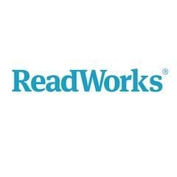

Teaching Instruction

- We will be reading and completing a book study of The Lightning Thief by Rick Riordan. I will read aloud each chapter and post to Seesaw for you to listen to as needed. If you prefer to have a hard copy of the book, you can purchase on Amazon https://www.amazon.com/Lightning-Thief-Percy-Jackson-Olympians-ebook/dp/B0036G8IQS/ref=tmm_kin_swatch_0?_encoding=UTF8&qid=1585154335&sr=1-1, or you can even reserve online from a Volusia County library. The library branches are closed, but they allow you to reserve books online and pick up outside at their branches.
- Each week we will do the following activities all related to the chapters we read: practice new vocabulary words, answer comprehension questions on the discussion board, and complete a quiz.
- I will assign one or two IXL codes to be completed by Friday.
- Every Thursday will be set aside for iReady reading lessons. You should spend about 45 minutes completing lessons.

Grading

You will receive one grade a week for this ELA course. This may be in the form of a Seesaw activity, Nearpod, NewsELA quiz, etc.

